Public Community Profile

Users  - Primary  - Community manager  - Secondary | Phase 1
Intended Outcome
- Organizers create their community profile as they want to introduce their communities to outsiders and prospective members.
Links
- …
- …
- …
- …
- …

Introduction
As we have created community profiles to introduce communities to the public, we also need to allow community managers who are interested to introduce their communities to create their own community profiles.

Product Requirement
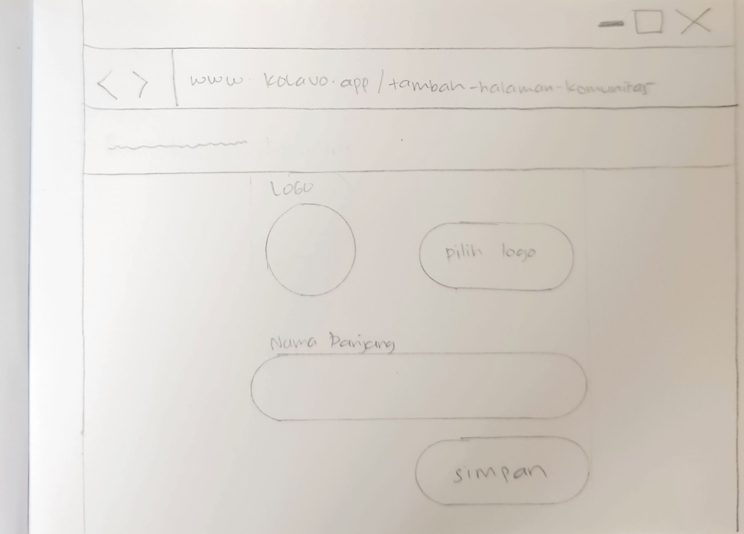

No. | User Stories | Scope | Acceptance Criteria
1 | As community managers I want to create my community page, so that my community can be represented publicly in Kolavo. | Community Page Creation Form | - Only logged in users can access community page creation form  - Not logged in users are redirected to login before accessing the form  - Form allows users to fill in information including:  - Logo  - Shortname  - Long name  - Color theme  - Domicile (Country, Province/State, City)  - Bio  - It allows users to save or cancel  - If users click save, community page is created and redirect to created community page
2 | As community managers, I don’t want the same community created, so members won’t be confused where to join. | Community Page Creation Warning | - Show list of match registered community as users typing community long name  - The list of community is clickable and redirect to related community page  - If name is same and user did not want to click the list, give warning about community page creation
3 | As Kolavo product team, I don’t want to input all cities around the world, because we don’t have the resources. | Users Domicile Data Input | - Data input by users is saved and able to reused  - List of domicile is shown as users typing  - Users can choose domicile from shown list
4 | As community managers, I would like to update my community profile, because we need to adapt to changes. | Community Profile Edit | - Only community managers who created community page can edit it  - Button to edit page is shown in community profile  - Logged in is required to edit community page

Design Requirement
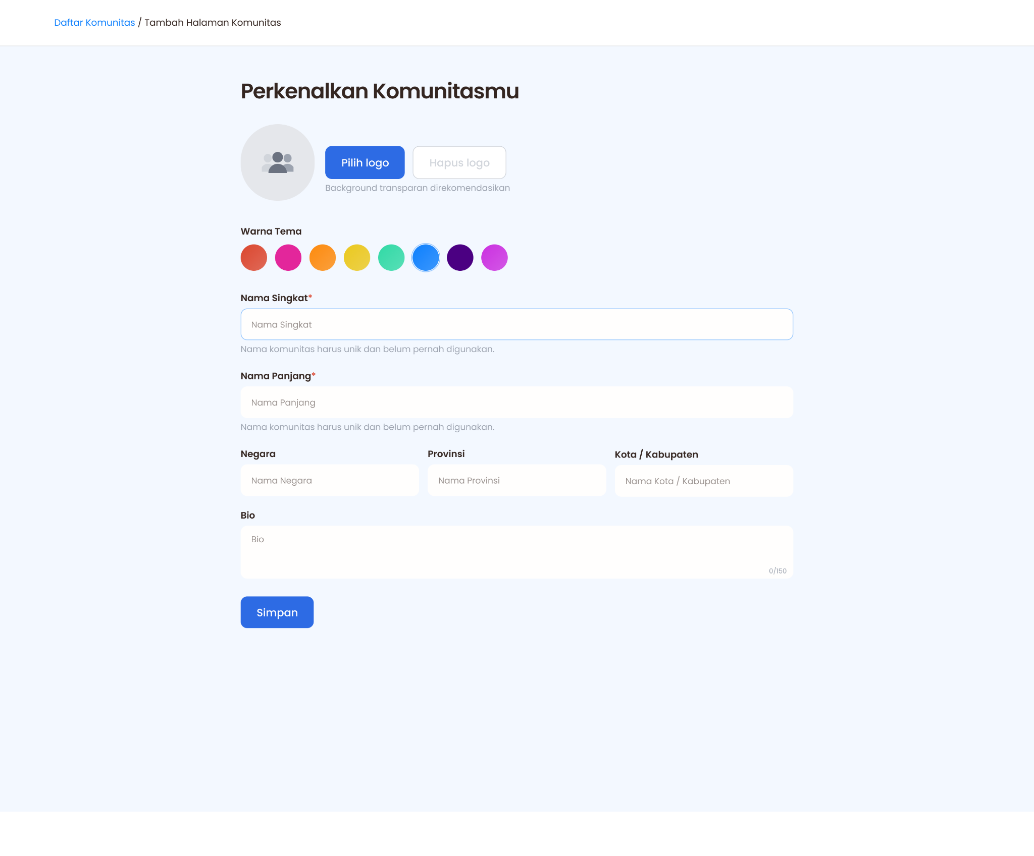
Reference from Figma Design (Create Community Page)
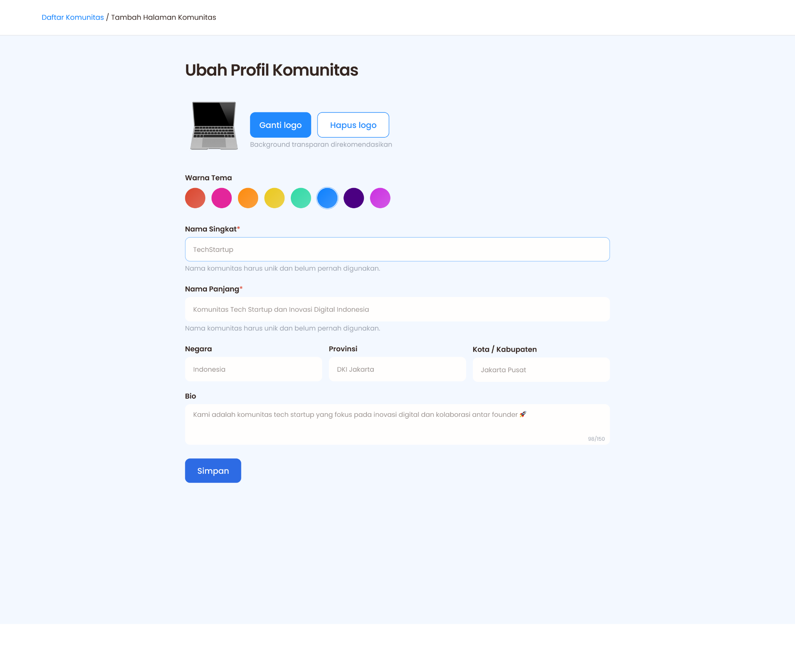
Reference from Figma Design (Edit Community Page)

Breadcrumbs
Design Intent | Ease users access homepage containing list of communities from community page
Content / Copy | Daftar Komunitas / Tambah Halaman Komunitas
Visual Requirement | - The placement is left align as Kolavo logo  - The color of clickable word is following community theme color  - The color of / and community short name is default #342621 (dark brown)  - Use Body S style which are:  - Font Family: Poppins, sans-serif  - Font Weight: 400  - Font Size: 14px  - Line Height: 21px  - Letter Spacing: 0px  - Text Color: #342621 (Dark Brown)  - Text Align: Left
Interaction Behavior | When click Daftar Komunitas, redirect to homepage/community list
Acceptance Criteria

Community Page Creation Form Layout
Design Intent | The header and form element should feel like one cohesive identity block, similar to a profile layout rather than a document.
Content / Copy | Includes header, community upload logo, short name, long name, country, province, city, bio, and save button.
Visual Requirement | Arrange header and form element in a horizontally balanced layout within the centered container. The spacing between logo and text should feel intentional and visually proportional.
Interaction Behavior | Static by default. Layout should maintain balance when profile copy becomes slightly longer or shorter.
Acceptance Criteria

Community Page Creation Form Header
Design Intent | To highlight the function of the Community Page Creation Form
Content / Copy | Perkenalkan Komunitasmu
Visual Requirement | - Font Family: Poppins, sans-serif  - Font Weight: 600 (Semi-Bold)  - Font Size: 32px  - Line Height: 38px  - Letter Spacing: -1px  - Text Color: #342621 (Dark Brown)  - Text Align: Left
Interaction Behavior | Static text. No hover or motion required.
Acceptance Criteria

Logo File Upload
Design Intent | To acquaint users the place of uploading community logo
Content / Copy | - Upload Button name based on state:  - No logo: Pilih logo  - Logo exists: Ganti logo  - Remove logo button: Hapus logo  - Info: Background transparan direkomendasikan
Visual Requirement | - Logo Preview  - Circle shape with organizer picture in it as attached  - Circle shape is light grey  - Organizer picture is dark grey  - The circle size is 24px  - Put at the left like reference  - Upload button  - Font Family: Poppins, sans-serif  - Font Weight: 500 (Medium)  - Font Size: 16px (base/default)  - Line Height: 1.5  - Text Color: White (#FFFFFD)  - Background Color: #5D9CEC (Blue Kolavo)  - Background color changes as color theme chosen  - Padding: 24px horizontal, 12px vertical  - Border Radius: 8px (rounded-lg)  - Hover Effect: Box shadow 2px 2px 8px rgba(0, 0, 0, 0.15)  - Put next logo preview and after space, before remove button.  - Button align: right  - Remove button  - Font Family: Poppins, sans-serif  - Font Weight: 500 (Medium)  - Font Size: 16px (base/default)  - Line Height: 1.5  - Text and Border Color (with logo): follow the theme color, otherwise #5D9CEC (Blue Kolavo)  - Text and Border Color (no logo): light grey  - Background Color: White (#FFFFFD)  - Padding: 24px horizontal, 12px vertical  - Border Radius: 8px (rounded-lg)  - Hover Effect: Box shadow 2px 2px 8px rgba(0, 0, 0, 0.15)  - Put next to upload button  - Button align: right  - Info  - Font Family: Poppins, sans-serif  - Font Weight: 400  - Font Size: 13px  - Line Height: 17px  - Letter Spacing: 0px  - Text Color: Light grey  - Text align: Left  - Put under buttons start from upload button
Interaction Behavior | - Opens browse picture when upload button clicked  - Show chosen picture in logo preview  - Remove chosen picture in logo preview when remove button clicked
Acceptance Criteria

Community Color Theme
Design Intent | To acquaint users the place of changing community color theme
Content / Copy | Label: Warna Tema
Visual Requirement | - Label  - Font Family: Poppins, sans-serif  - Font Weight: 600  - Font Size: 14px  - Line Height: 17px  - Letter Spacing: 0px  - Text Color: #342621 (Dark Brown)  - Text align: left  - Color button  - Circle 40x40px  - Give same linear effect to all buttons  - List of color:  - #DB462E  - #E3269B  - #FD8A0D  - #EBC81E  - #31D9A5  - #0D7FFD  - #4B0082  - #CB30E0
Interaction Behavior | - Give outer with same color chosen  - Change main background color to chosen color with 5% transparency  - Change button color to chosen color  - Change link color to chosen color  - The changes affect to every mentioned element in all pages related to the saved community setup
Acceptance Criteria

Community Short Name
Design Intent | To acquaint users the place of inputting community short name
Content / Copy | - Label: Nama Singkat  - Field: Nama Singkat  - Info: Nama komunitas harus unik dan belum pernah digunakan.
Visual Requirement | - Label  - Font Family: Poppins, sans-serif  - Font Weight: 600  - Font Size: 14px  - Line Height: 17px  - Letter Spacing: 0px  - Text Color: #342621 (Dark Brown)  - Text align: left  - Field  - Left and right align  - Default Border color: none  - Active border color: theme color transparent 50%  - Hight: 48 px  - Vertical padding: 12 px  - Horizontal padding: 16 px  - Fill: #FFFEFD  - Field Label  - Font Family: Poppins, sans-serif  - Font Weight: 400  - Font Size: 13px  - Line Height: 17px  - Letter Spacing: 0px  - Text Color:dark grey  - Text align: left  - Field Text  - Font Family: Poppins, sans-serif  - Font Weight: 400  - Font Size: 13px  - Line Height: 17px  - Letter Spacing: 0px  - Text Color: dark brown  - Text align: left  - Info  - Font Family: Poppins, sans-serif  - Font Weight: 400  - Font Size: 13px  - Line Height: 17px  - Letter Spacing: 0px  - Text Color: #9CA3AF  - Text align: Left  - Put under the field
Interaction Behavior | - When activated border change to thin transparent chosen theme color  - When users typing, show list of clickable registered communities whose name are similar  - Open clicked community profile, when one of those names is clicked
Acceptance Criteria

Community Long Name
Design Intent | To acquaint users the place of inputting community long name
Content / Copy | - Label: Nama Panjang  - Field: Nama Panjang  - Info: Nama komunitas harus unik dan belum pernah digunakan.
Visual Requirement | - Label  - Font Family: Poppins, sans-serif  - Font Weight: 600  - Font Size: 14px  - Line Height: 17px  - Letter Spacing: 0px  - Text Color: #342621 (Dark Brown)  - Text align: left  - Field  - Left and right align  - Default Border color: none  - Active border color: theme color transparent 50%  - Hight: 48 px  - Vertical padding: 12 px  - Horizontal padding: 16 px  - Fill: #FFFEFD  - Field Label  - Font Family: Poppins, sans-serif  - Font Weight: 400  - Font Size: 13px  - Line Height: 17px  - Letter Spacing: 0px  - Text Color:dark grey  - Text align: left  - Field Text  - Font Family: Poppins, sans-serif  - Font Weight: 400  - Font Size: 13px  - Line Height: 17px  - Letter Spacing: 0px  - Text Color: dark brown  - Text align: left  - Info  - Font Family: Poppins, sans-serif  - Font Weight: 400  - Font Size: 13px  - Line Height: 17px  - Letter Spacing: 0px  - Text Color: #9CA3AF  - Text align: Left  - Put under the field
Interaction Behavior | - When activated border change to thin transparent chosen theme color  - When users typing, show list of clickable registered communities whose name are similar  - Open clicked community profile, when one of those names is clicked
Acceptance Criteria

Community Country Location
Design Intent | To acquaint users the place of inputting community country location
Content / Copy | - Label: Negara  - Field: Nama Negara
Visual Requirement | - Label  - Font Family: Poppins, sans-serif  - Font Weight: 600  - Font Size: 14px  - Line Height: 17px  - Letter Spacing: 0px  - Text Color: #342621 (Dark Brown)  - Text align: left  - Field  - Left and right align  - Border: none  - Active border color: theme color transparent 50%  - Hight: 48 px  - Weight: 270px  - Vertical padding: 12 px  - Horizontal padding: 16 px  - Fill: #FFFEFD  - Field Label  - Font Family: Poppins, sans-serif  - Font Weight: 400  - Font Size: 13px  - Line Height: 17px  - Letter Spacing: 0px  - Text Color:dark grey  - Text align: left  - Field Text  - Font Family: Poppins, sans-serif  - Font Weight: 400  - Font Size: 13px  - Line Height: 17px  - Letter Spacing: 0px  - Text Color: dark brown  - Text align: left
Interaction Behavior | - When activated border change to thin transparent chosen theme color
Acceptance Criteria

Province Location
Design Intent | To acquaint users the place of inputting community province location
Content / Copy | - Label: Provinsi  - Field: Nama Provinsi
Visual Requirement | - Label  - Font Family: Poppins, sans-serif  - Font Weight: 600  - Font Size: 14px  - Line Height: 17px  - Letter Spacing: 0px  - Text Color: #342621 (Dark Brown)  - Text align: left  - Field  - Left and right align  - Border: none  - Active border color: theme color transparent 50%  - Hight: 48 px  - Weight: 270px  - Vertical padding: 12 px  - Horizontal padding: 16 px  - Fill: #FFFEFD  - Field Label  - Font Family: Poppins, sans-serif  - Font Weight: 400  - Font Size: 13px  - Line Height: 17px  - Letter Spacing: 0px  - Text Color:dark grey  - Text align: left  - Field Text  - Font Family: Poppins, sans-serif  - Font Weight: 400  - Font Size: 13px  - Line Height: 17px  - Letter Spacing: 0px  - Text Color: dark brown  - Text align: left
Interaction Behavior | - When activated border change to thin transparent chosen theme color
Acceptance Criteria

Community City Location
Design Intent | To acquaint users the place of inputting community city location
Content / Copy | - Label: Kota / Kabupaten  - Field: Nama Kota / Kabupaten
Visual Requirement | - Label  - Font Family: Poppins, sans-serif  - Font Weight: 600  - Font Size: 14px  - Line Height: 17px  - Letter Spacing: 0px  - Text Color: #342621 (Dark Brown)  - Text align: left  - Field  - Left and right align  - Border: none  - Active border color: theme color transparent 50%  - Hight: 48 px  - Weight: 270px  - Vertical padding: 12 px  - Horizontal padding: 16 px  - Fill: #FFFEFD  - Field Label  - Font Family: Poppins, sans-serif  - Font Weight: 400  - Font Size: 13px  - Line Height: 17px  - Letter Spacing: 0px  - Text Color:dark grey  - Text align: left  - Field Text  - Font Family: Poppins, sans-serif  - Font Weight: 400  - Font Size: 13px  - Line Height: 17px  - Letter Spacing: 0px  - Text Color: dark brown  - Text align: left
Interaction Behavior | - When activated border change to thin transparent chosen theme color
Acceptance Criteria

Bio
Design Intent | To acquaint users the place of inputting text they want to show
Content / Copy | - Label: Bio  - Field: Bio  - Alert: 0/150
Visual Requirement | - Label  - Font Family: Poppins, sans-serif  - Font Weight: 600  - Font Size: 14px  - Line Height: 17px  - Letter Spacing: 0px  - Text Color: #342621 (Dark Brown)  - Text align: left  - Field  - Left and right align  - Border: none  - Active border color: theme color transparent 50%  - Hight: 80 px  - Vertical padding: 12 px  - Horizontal padding: 16 px  - Fill: #FFFEFD  - Field Label  - Font Family: Poppins, sans-serif  - Font Weight: 400  - Font Size: 13px  - Line Height: 17px  - Letter Spacing: 0px  - Text Color:dark grey  - Text align: left  - Field Text  - Font Family: Poppins, sans-serif  - Font Weight: 400  - Font Size: 13px  - Line Height: 17px  - Letter Spacing: 0px  - Text Color: dark brown  - Text align: left  - Alert  - Font Family: Poppins, sans-serif  - Font Weight: 400  - Font Size: 10px  - Line Height: 17px  - Letter Spacing: 0px  - Text Color: Light grey  - Text align: Right  - Put at the right bottom
Interaction Behavior | - Field: When activated border change to thin transparent chosen theme color  - Alert:  - The numerator showing number of character as users typing  - Stop inputting when character reach 150
Acceptance Criteria

Save Button
Design Intent | To allow user saving the information filled in the form
Content / Copy | Simpan
Visual Requirement | - Font Family: Poppins, sans-serif  - Font Weight: 500 (Medium)  - Font Size: 16px (base/default)  - Line Height: 1.5  - Text Color: White (#FFFFFD)  - Fill Color: main theme color chosen  - Padding: 24px horizontal, 12px vertical  - Border Radius: 8px (rounded-lg)  - Hover Effect: Box shadow 2px 2px 8px rgba(0, 0, 0, 0.15)
Interaction Behavior | - Fill color changed as theme color chosen  - On mouse hover, button color stays the same.  - Add subtle shadows on the right, left, and bottom side of the button.  - No layout shift.  - When clicked data is saved and redirect to community page just created with different visual and copy of Call to Action Button
Acceptance Criteria

Call to Action Button
Design Intent | Ease community managers to find where to edit community profile
Content / Copy | - Ubah Profil
Visual Requirement | - Font Family: Poppins, sans-serif  - Font Weight: 500 (Medium)  - Background Color: light grey  - Text Color: dark brown  - Padding: 24px horizontal (px-6), 12px vertical (py-3)  - Border Radius: 8px (rounded-lg)
Interaction Behavior | - Hover Effect: Box shadow 2px 2px 8px rgba(0, 0, 0, 0.15)  - Shadow color: chosen theme color  - Transition: Shadow transition  - Opens edit community profile which is the community page creation form with header text: Ubah Profil Komunitas
Acceptance Criteria | - CTA button label changes based on user role and membership setup status.  - For community page owners when membership is not set up, CTA shows Atur Keanggotaan.  - For community page owners when membership is set up, CTA shows Ubah Profil.  - CTA uses Poppins with font weight 500.  - CTA uses 24px horizontal padding, 12px vertical padding, and 8px border radius.  - Ubah Profil use light grey as background and dark brown text.  - On hover, CTA shows box shadow 2px 2px 8px rgba(0, 0, 0, 0.15).  - Hover transition is applied to shadow.  - Hover shadow color follows the selected community theme color.

Engineering Requirement

Questions

